**Objective**:

To assess your knowledge on

1. How to connect to Snowflake from dbt
2. Creating models in dbt
3. Configuring sources in dbt
4. SQL and Analytical Skills

**Data for this hands-on:**

The data that we are going to use for this hands-on is look ecommerce data. A synthetic data provided by google. <https://www.kaggle.com/datasets/daichiuchigashima/thelook-ecommerce>

You will download 7 tables, but we will be using only below 4 tables

1. Users
2. Products
3. Orders
4. Order Items.

**Step 1: Data Loading**

Create a database ELOOK_COMMERCE and create a Schema RAW

Create 4 tables Orders, Order_Items, Users and Products by loading the data into snowflake by using **Add Data** option in snowflake. Look into below link to know more about how to load data into snowflake.

<https://docs.snowflake.com/en/user-guide/data-load-web-ui#create-a-table-when-loading-a-file>

Note: Don’t do anything in Table Definition Dialog, just click **load**.

**Step 2: Understanding the data**

Order_Items is related to Products, Orders and Users by Product_Id, Order_Id and User_Id respectively.

Similarly, Orders is connected to Users by User_Id column.

For this hands-on Let us assume below primary keys

1. Users – Id
2. Products – product_id
3. Orders – order_id
4. Order_Items – order_id, product_id

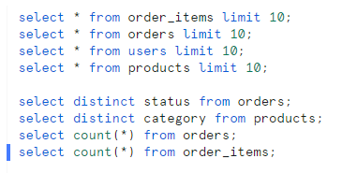Understand the data by using following queries, below is just an example.

**Step 3: Configuring DBT**

Create a project in dbt,

1. Name your project in the format <your_first_name>_<last_name>_hands_on_1
2. Configure Snowflake Connection. Configure the project to create your models in Database and schema of your wish. (Make it outside of ELOOK_COMMERCE database)
3. Configure the github connection
4. Configure the sources for above 4 tables which we created in above step.

**Step 4: Staging Layer**

Staging Layer: 4 models

1. Stg_Orders
2. Stg_Order_Items
3. Stg_Products
4. Stg_Users

Select All the columns from all the table except **Inventory_Item_id** from **order_Items** table in this staging layer.

Also, **convert all the timestamp columns** like created_at, shipped_at from varchar to timestamp.

***Note***: You Might need to use some string functions and type casting functions. Get help from your friend google how to do this conversion if you want.

**Step 5: Cleaning Layer**

You are allowed to create any number of layers / models between Staging Layer and Cleaning Layer

Cleaning Layer: 1 model

1. Cleaned_Order_Items

One Order_Id and Product_Id combination should have only one record in Order_Items table. If there are multiple records available for same Order_Id and Product_Id, you should take only one record with latest Created_At date.

Materialize this model as table.

Extra Trial: Try to materialize stg_order_items as

***Note***: You might need to use rank function for this issue.

Tip: Break Stg_Order_Items into two models, one with no duplicate records and another with duplicate records, Clean the duplicate records and combine both the models.

**Step 6: Final Layer**

Again, you are allowed to create any number of models between Cleaning Layer and Final Layer

Final Layer: 2 models

1. Top_5_Users:
   1. Find the top 5 users who spent more money (consider Sale_Price from order_items table) in our company. **Orders should not be in Cancelled or Returned status.**
   2. Three columns should be there in this model. FirstName, LastName, TotalAmountSpent

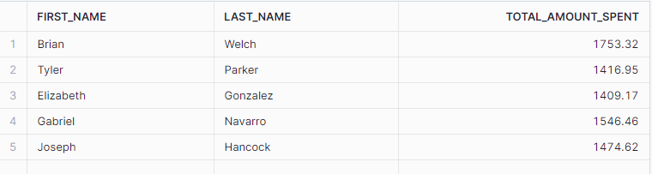

1. Top_5_Category:
   1. Find the top 5 product category which get us more money (consider Sale_Price from order_items table). Again, **Orders should not be in Cancelled or Returned state.**
   2. Two columns should be there in this model. Category, TotalRevenue.

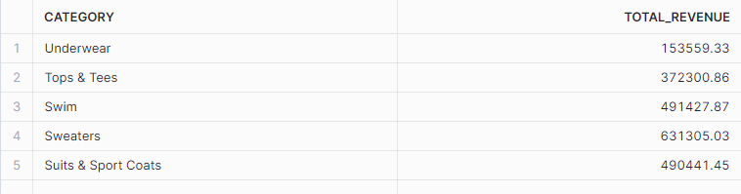

Output:

You have to provide a word document with below screenshots.

1. All 4 stage models
2. One Cleaned Model
3. Two Final Models
4. Success screenshot of dbt run command
5. Screenshot of DAG after running dbt docs generate command.
6. Two screenshots with the output of Snowflake tables **Top_5_Users, Top_5_Category.**

***Make sure all the models screenshot have project name on its left side***.